A TIMES INVESTIGATION

‘YOU WANT A DESCRIPTION OF HELL?’ OXYCONTIN’S 12-HOUR PROBLEM
by HARRIET RYAN, LISA GIRION AND SCOTT GLOVER
MAY 5, 2016
The drugmaker Purdue Pharma launched OxyContin two decades ago with a bold marketing claim: One dose relieves pain for 12 hours, more than twice as long as generic medications.
Patients would no longer have to wake up in the middle of the night to take their pills, Purdue told doctors. One OxyContin tablet in the morning and one before bed would provide “smooth and sustained pain control all day and all night.”

1996

OxyContin Press Release
When Purdue unveiled OxyContin in 1996, it touted 12-hour duration.
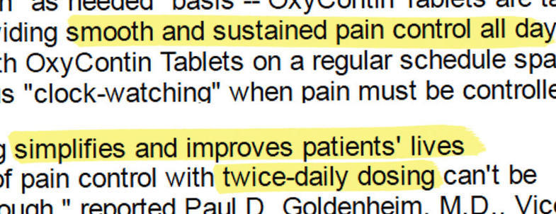

On the strength of that promise, OxyContin became America’s bestselling painkiller, and Purdue reaped $31 billion in revenue.
But OxyContin’s stunning success masked a fundamental problem: The drug wears off hours early in many people, a Los Angeles Times investigation found. OxyContin is a chemical cousin of heroin, and when it doesn’t last, patients can experience excruciating symptoms of withdrawal, including an intense craving for the drug.
The problem offers new insight into why so many people have become addicted to OxyContin, one of the most abused pharmaceuticals in U.S. history.

The Times investigation, based on thousands of pages of confidential Purdue documents and other records, found that:
- Purdue has known about the problem for decades. Even before OxyContin went on the market, clinical trials showed many patients weren’t getting 12 hours of relief. Since the drug’s debut in 1996, the company has been confronted with additional evidence, including complaints from doctors, reports from its own sales reps and independent research.
- The company has held fast to the claim of 12-hour relief, in part to protect its revenue. OxyContin’s market dominance and its high price — up to hundreds of dollars per bottle — hinge on its 12-hour duration. Without that, it offers little advantage over less expensive painkillers.
- When many doctors began prescribing OxyContin at shorter intervals in the late 1990s, Purdue executives mobilized hundreds of sales reps to “refocus” physicians on 12-hour dosing. Anything shorter “needs to be nipped in the bud. NOW!!” one manager wrote to her staff.
- Purdue tells doctors to prescribe stronger doses, not more frequent ones, when patients complain that OxyContin doesn’t last 12 hours. That approach creates risks of its own. Research shows that the more potent the dose of an opioid such as OxyContin, the greater the possibility of overdose and death.
- More than half of long-term OxyContin users are on doses that public health officials consider dangerously high, according to an analysis of nationwide prescription data conducted for The Times.
Over the last 20 years, more than 7 million Americans have abused OxyContin, according to the federal government’s National Survey on Drug Use and Health. The drug is widely blamed for setting off the nation’s prescription opioid epidemic, which has claimed more than 190,000 lives from overdoses involving OxyContin and other painkillers since 1999.

GET INVOLVED

Tell us your story
The internal Purdue documents reviewed by The Times come from court cases and government investigations and include many records sealed by the courts. They span three decades, from the conception of OxyContin in the mid-1980s to 2011, and include emails, memos, meeting minutes and sales reports, as well as sworn testimony by executives, sales reps and other employees.
The documents provide a detailed picture of the development and marketing of OxyContin, how Purdue executives responded to complaints that its effects wear off early, and their fears about the financial impact of any departure from 12-hour dosing.
Reporters also examined Food and Drug Administration records, Patent Office files and medical journal articles, and interviewed experts in pain treatment, addiction medicine and pharmacology.
Experts said that when there are gaps in the effect of a narcotic like OxyContin, patients can suffer body aches, nausea, anxiety and other symptoms of withdrawal. When the agony is relieved by the next dose, it creates a cycle of pain and euphoria that fosters addiction, they said.

PURDUE'S RESPONSE

Purdue Pharma issues statement on OxyContin report; L.A. Times responds
OxyContin taken at 12-hour intervals could be “the perfect recipe for addiction,” said Theodore J. Cicero, a neuropharmacologist at the Washington University School of Medicine in St. Louis and a leading researcher on how opioids affect the brain.
Patients in whom the drug doesn’t last 12 hours can suffer both a return of their underlying pain and “the beginning stages of acute withdrawal,” Cicero said. “That becomes a very powerful motivator for people to take more drugs.”

The cycle of addiction
Peter Przekop, a neuroscientist and physician who oversees the treatment of painkiller addicts at the Betty Ford Center in Rancho Mirage, said that repeated episodes of withdrawal from OxyContin “absolutely” raise the risk that patients will abuse the medication.
“You are messing with those areas of the brain that are involved in addiction, and you are going to get the person dependent on it,” he said.
The Times sought comment from Purdue’s scientists and executives. At the company’s request, the newspaper submitted detailed questions in writing. Purdue responded with a one-page statement noting that the FDA approved OxyContin as a 12-hour drug.
“Scientific evidence amassed over more than 20 years, including more than a dozen controlled clinical studies, supports FDA’s approval of 12-hour dosing for OxyContin,” Purdue’s chief medical officer, Dr. Gail Cawkwell, said.
Company officials said in the same statement that “the people at Purdue have dedicated themselves to helping address our nation’s opioid epidemic.”

